**Version Control System**

<https://www.youtube.com/watch?v=vMGq5p2m6Ak>

DEVOPS - Types of Version Control Systems - Centralized Vs Distributed | by DURGA Sir

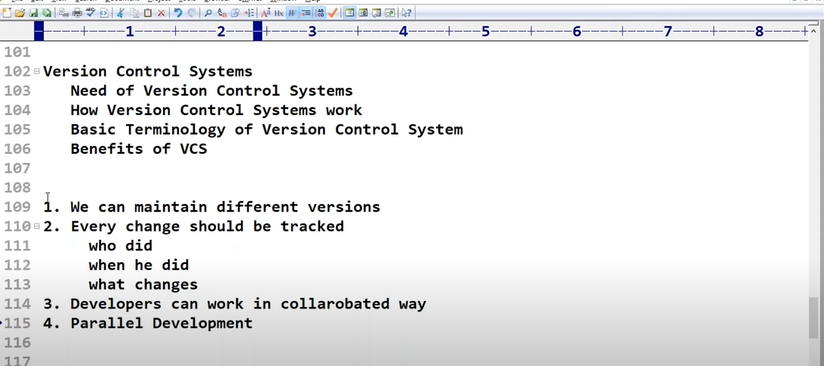

There are 3 types of Version Control System [VCS]:

1. Centralized VCS like SVN, CVS, Perforce, TFS and ClearCase
2. Distributed VCS like GIT, Mercurial and Fossil
3. Distributed VCS with Remote repository

**Centralized VCS:** There is only working files get stores on developers system and at central repository they commit their work.

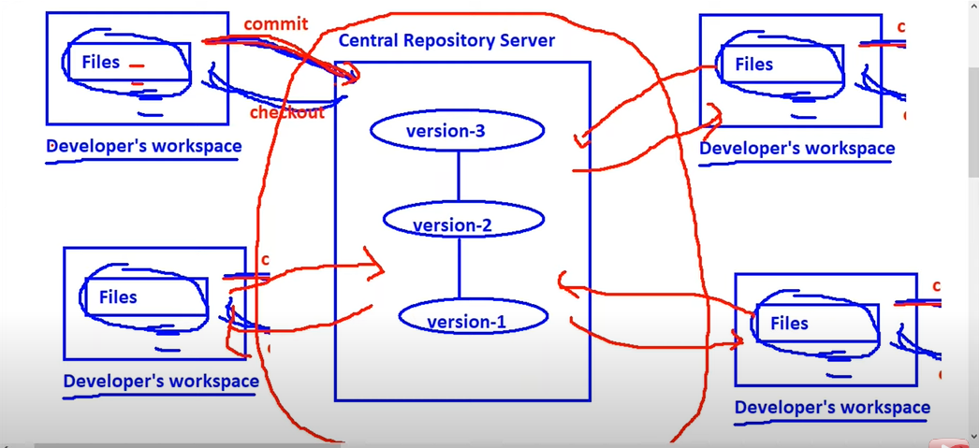

**Distributed VCS:**

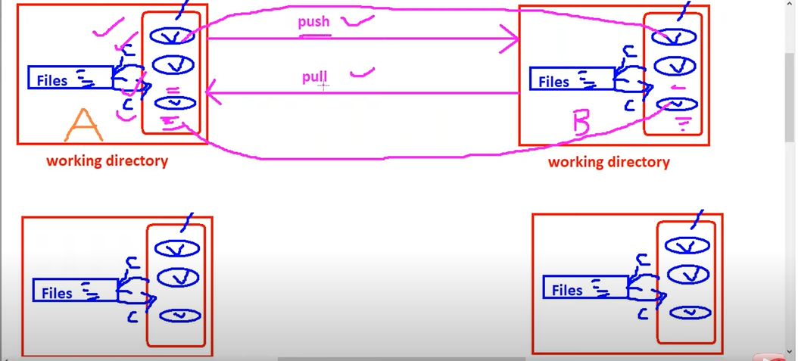

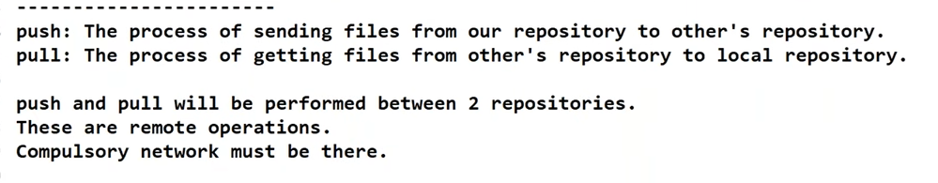

**Distributed VCS with Remote repository:**

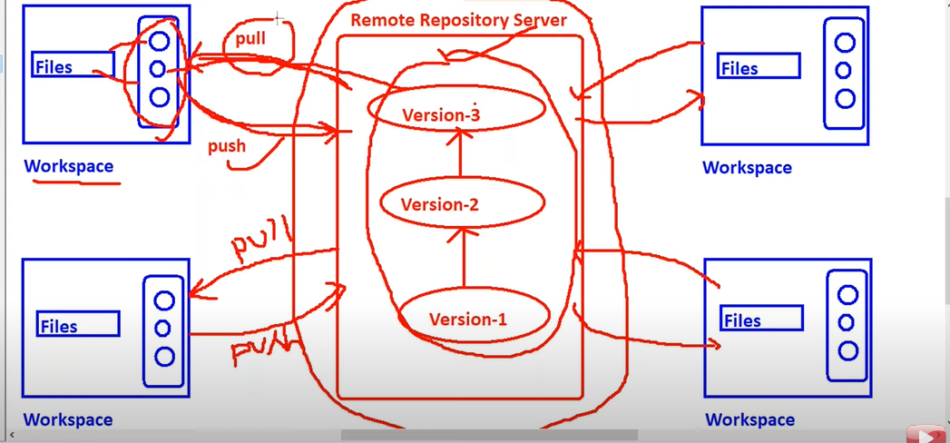

Remote repository server examples are: GitHub, GitLab, BitBucket, Cloud platform

**Git Architecture:**

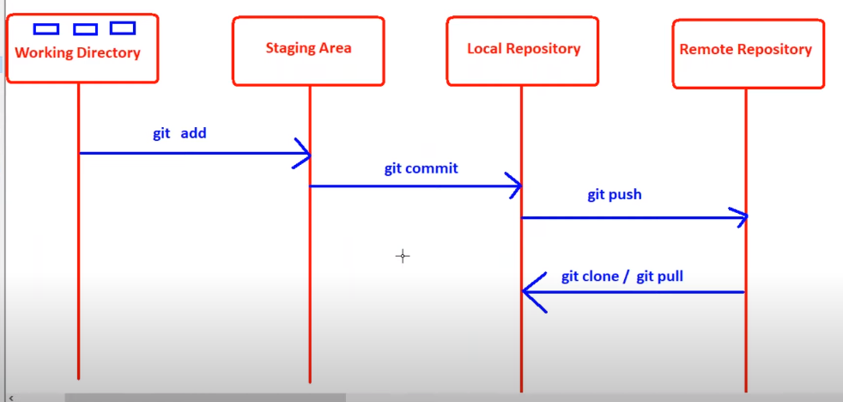

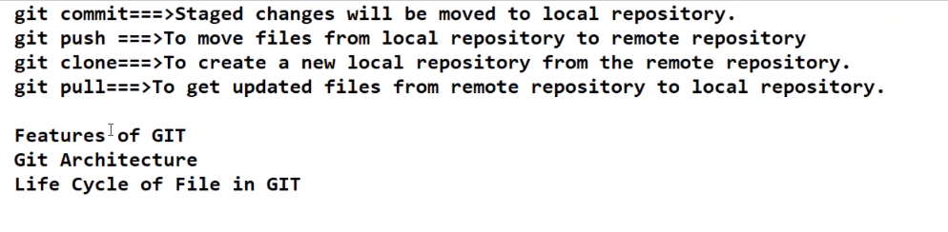

git ls-files 🡺 Cmd will tell you, what are the files tracked by git.

git log -> cmd will tell you how many version are available of a file which are committed with commit details.

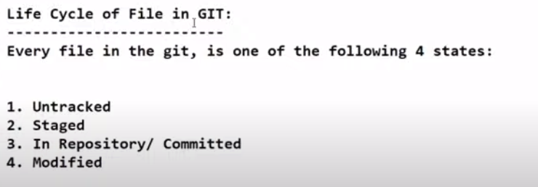

**Git reset:**

<https://www.howtogeek.com/devops/how-does-git-reset-actually-work-soft-hard-and-mixed-resets-explained/#:~:text=git%20reset%20%2D%2Dsoft%20%2C%20which,know%20what%20you're%20doing>

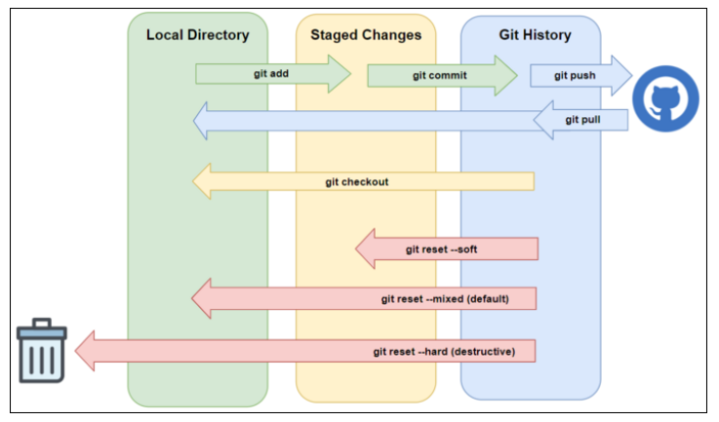

**Git rebase vs git merge:**

<https://www.edureka.co/blog/git-rebase-vs-merge/#What-is-Merging>?

**Git Workflow:**

<https://blog.bytebytego.com/p/ep-40-git-workflow>

